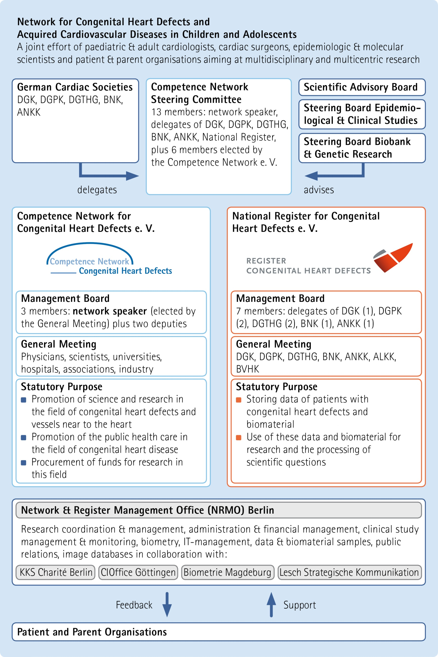


Template
Application for the use of data/biomaterial and/or the infrastructure of the National Register for Congenital Heart Defects (NRCHD) for research studies

Please e-mail to  ubauer@kompetenznetz-ahf.de  CEO of the National Register for Congenital Heart Defects (NRCHD) and the Competence Network for Congenital Heart Defects (CNCHD)  Dr. Ulrike Bauer | To be completed by the Management Office:  Project application ID: _____________  Date of receipt: ___________________

Details of this proposal will be treated as confidential
1. Research topic/title

2. Principal investigator(s)
First name/surname
Organisation/institution
Address
Tel./Fax
Email
Co-investigator(s)
3. Planned project duration
From: Until:
4. Background/state of the art

5. Research questions and aims

6. Hypothesis

7. Feasibility (power calculation etc.)

8. Relevance of results

9. Study design

10. Methods

11. Description of patient population
Sample size:

Diagnoses/phenotype:

Inclusion/exclusion criteria:

12 Detailed description of data that are required for evaluation/calculation
Data that we generally provide: sex, age, main and secondary diagnoses, hereditary, fetal and neonatal diagnoses (linked to IPCCC and/or ICD10). Additional data in the case of biomaterial: age at sampling
All further anamnestic and clinical data upon request (please add a table, if appropriate)

13. Required biomaterial (if applicable)
Type/amount of samples

14. Detailed information concerning funding

15. Vote of your Ethics Committee available?

16. The applicant’s institution actively
recruits patients for the National Register for Congenital Heart Defects
collects blood/DNA and/or tissue samples for research purposes
17. Applicants agree with the regulations on the use of data / samples and the CNCHD/NRCHD publication guidelines
18. References

