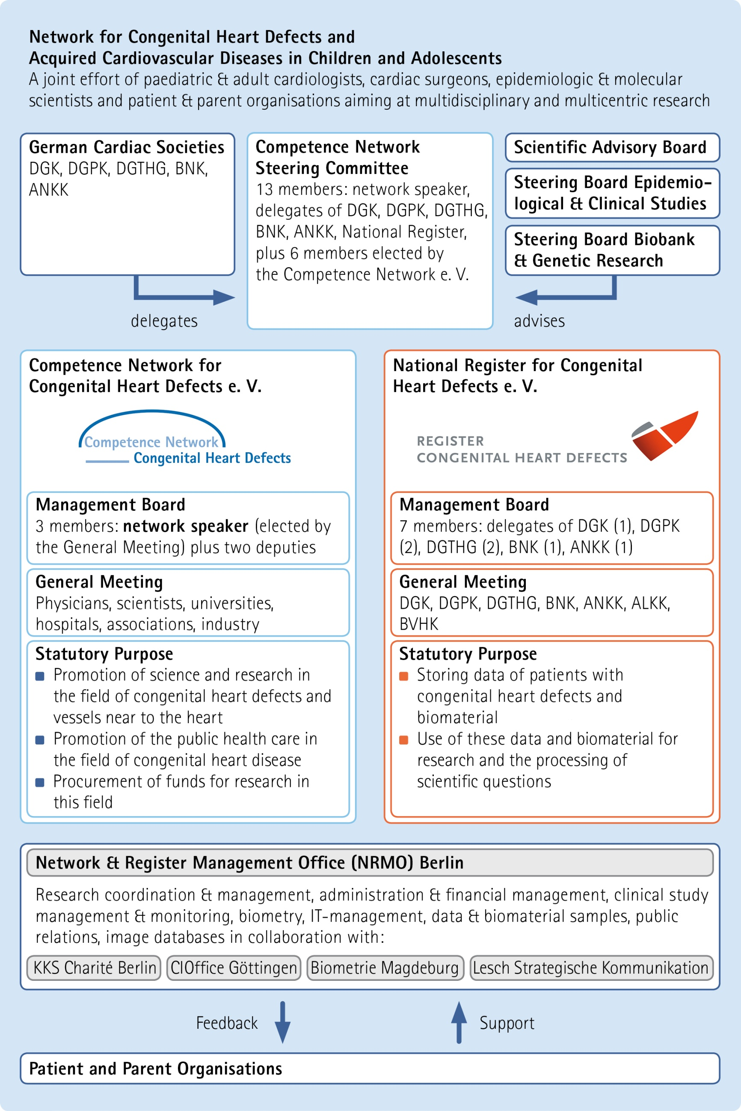


INQUIRY
Regarding the use of data/biomaterial and/or the infrastructure of the Competence Network and the National Register for Congenital Heart Defects

Please e-mail to
ubauer@kompetenznetz-ahf.de; pickardt@kompetenznetz-ahf.de;

(Details of this inquiry will be treated as confidential)

1 Research topic/title

2 Principal investigator(s)
First name/surname
Organisation/institution
Address:
Tel./Fax:
Email:
Co-investigator(s):
3 Short description of research question and aims

4 Description of patient population
Diagnoses, phenotype, sample size, inclusion/exclusion criteria

5 Detailed description of data that are required for evaluation/calculation
Data that we generally provide: sex, age, main and secondary diagnoses, hereditary, fetal and neonatal diagnoses (linked to IPCCC and/or ICD10). Additional data in the case of biomaterial: age at sampling
All further anamnestic and clinical data upon request (please add a table, if appropriate)

6 Required biomaterial (if applicable)
Type/amount of samples

